Enterprise Infrastructure and Networks – IT-520-A

Mallika Regulla

Marymount University

1. IP address of my computer is 10.0.0.108

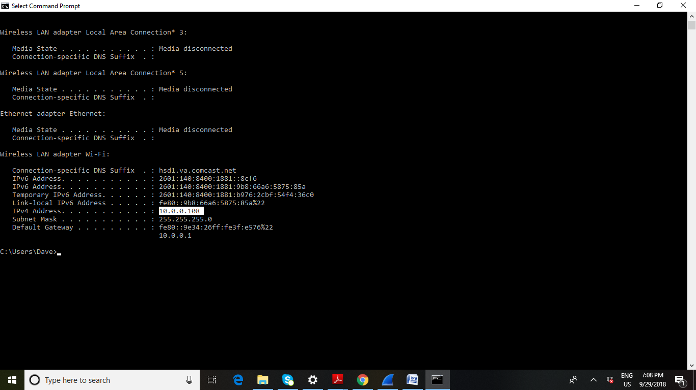

1. Total length of the datagram is 466

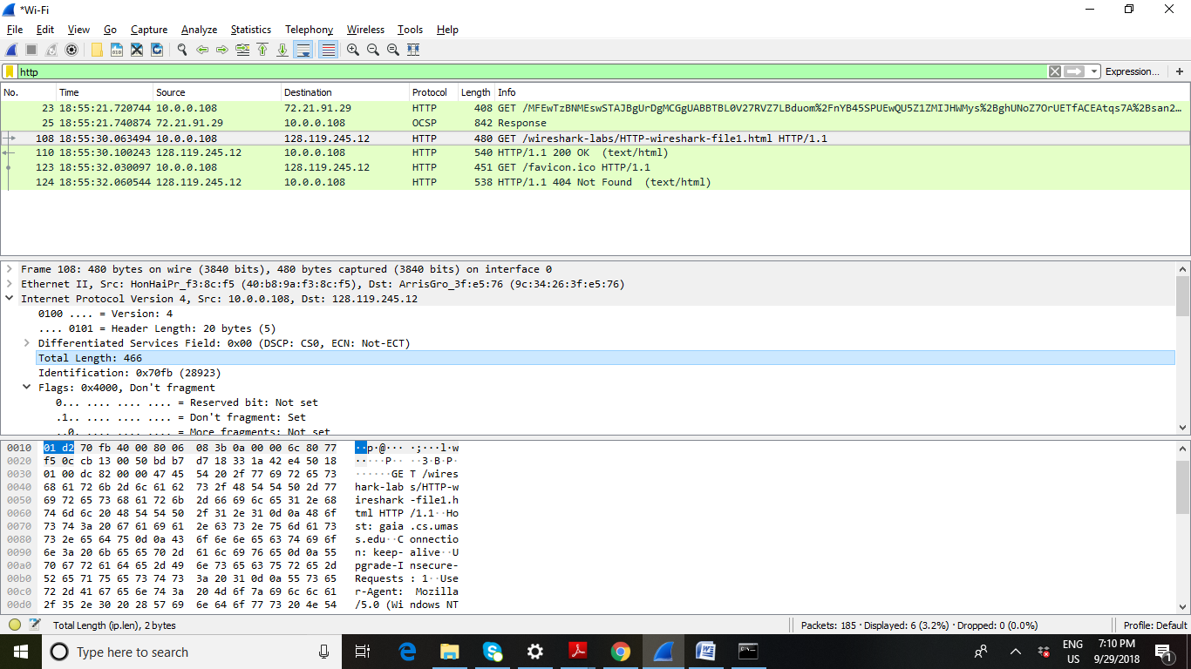

1. The datagram has not been fragmented

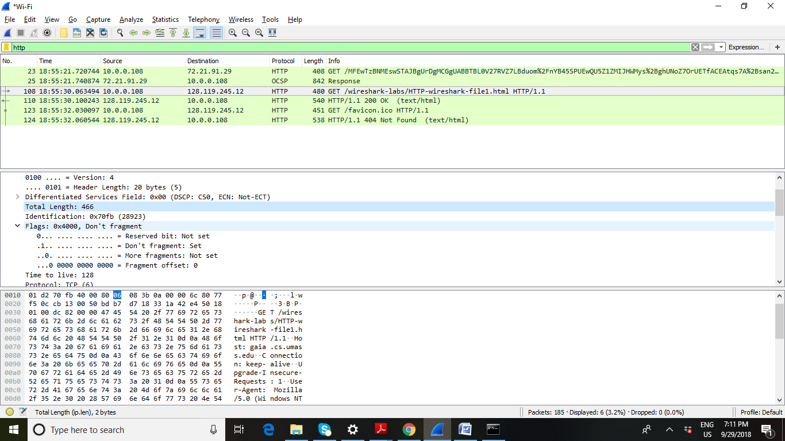

1. There are 20 bytes in the IP header

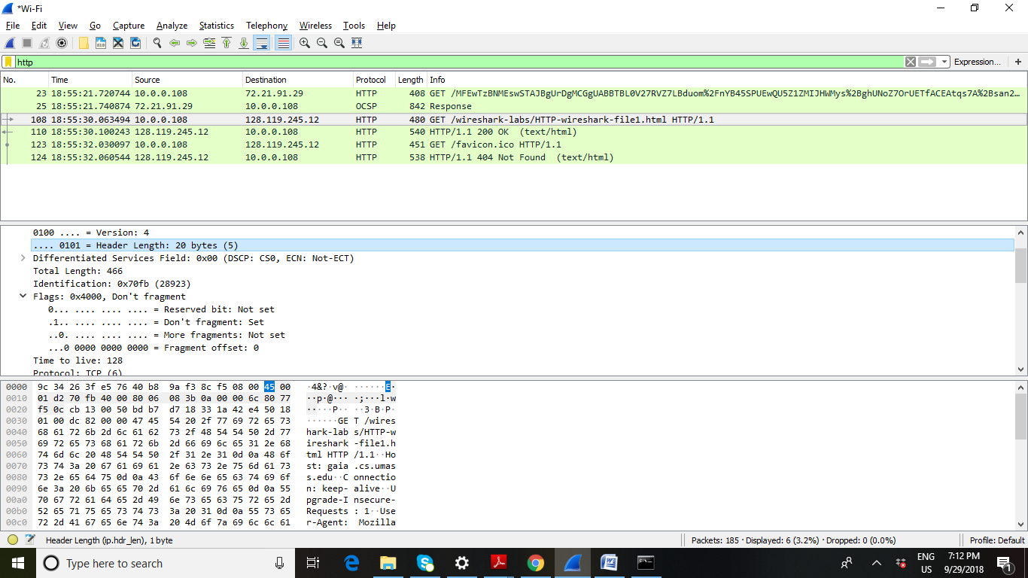

1. The total of the payload is 446 bytes

In this case, the length of the IP header is 20 bytes and the total length is 466 bytes. Therefore, the payload of the IP datagram = total length – IP header length

= 466-20

= 446

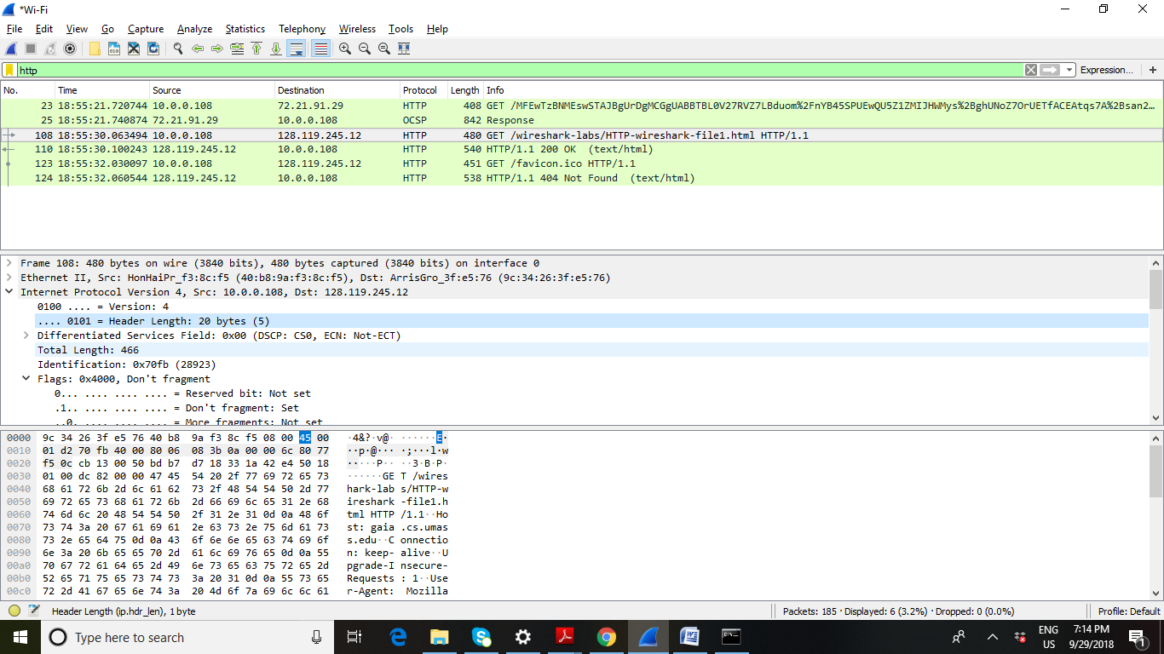

GET print pdf:



OK Print pdf:

